Mariyan Marinov
mariyan87@gmail.com
Ruse, Bulgaria

Experience

Nov 2024 – APR 2026

senior .net full stack engineer / tech lead, momentus technologies
Event and venue management system: cloud platform (Aurelia) with integrated CRM, event management, reporting and web portals(angular) for space booking, event planning, etc. Tech stack: .net framework/.net core, Angular, Aurelia, MSSQL, Azure, distributed systems, integrations, Github Copilot Agents
Responsibilities: development focused on architecture, scalability, and AI-assisted delivery; supervising, mentorship, taking part in architecture and development strategy of features, code reviews

DEC 2019 – Nov 2024

Founder and Lead Developer (contractor), Sharp it Ltd.
Providing development services with the following tech stack: Angular/React, bootstrap, .net core(EF, WebApi, MSSQL/PostgreSQL), NodeJS, AWS(S3, Cassandra, Route53, API Gateway, ECR, ECS, lambda), Azure, GitHub actions, Microservices, CICD. I offer comprehensive B2B development services, including code reviews and active participation in implementation strategy decisions. My focus is on delivering high-quality, scalable solutions while ensuring best practices and efficient development processes.
- [KPMG.com] KPMG – Audit Engagement Management Platform: Enterprise platform used to support and streamline the full audit lifecycle. The system included workflow orchestration, approval processes, compliance tracking, reporting, role-based access control, audit traceability, and business process management in a highly regulated environment. Contributed to discussions, backend/frontend development, and modernization initiatives within a large-scale distributed platform. Tech stack: .net, Azure, MS Graph, RabbitMQ, MassTransit
- [Fugro.com] Road data and pavement evaluation web project: Analysis and reporting of road condition on top of processed images of road pavement and road-surrounding object. Responsibilities: e2e development focused on architecture, and AI-assisted delivery; supervising, mentorship, ownership of features, code reviews. Tech stack: Angular, .net core, dapper, PostgreSQL, AWS (S3, ECR, ECS, API gateway, Route53), GitHub actions, auth0, Github Copilot Agents. Working with Geo data – PostGIS functions, shapefiles, GeoJSON, ArcGIS
- [pcg.io] - Implemented continuous data migration from multiple MSSQL on premise servers to AWS S3 using CDK and DMS.
- [pcg.io] - Cookie manager: app to configure cookie preferences, popup designer for cookie consents, etc. Technologies used: React, NodeJS, lambda, Cassandra keyspaces, S3
- [Microsoft] - Implemented internal app for Microsoft Machine Learning department: created an Angular+.NET Core reporting app to help Machine Learning team with their data analysis. (.net core, Angular, bootstrap, EF core, MSSQL, Aether, Azure)

August 2018 – MAY 2021

.net full stack developer, Sirma solutions
C# backend and UI Web development – c# .net 4.6, .net core, WebApi, Angular 2+, knockoutJS, bootstrap, EF, EF core, MSSQL, RestApi;
SOLID principles, full project lifecycle, DI

Worked on Grants management system (FinTech) for public institutions in donor countries (from EFTA) and beneficiary countries (from the EU) that share responsibility for the EEA and Norway Grants. (https://eeagrants.org, https://grace.eeagrants.org/)

june 2014 – January 2020

.net full stack developer, contractor to tarmin
C# Desktop and Web UI development - WinForms, Web Services, ASP.NET Core MVC, jQuery, bootstrap, Azure
Worked on their own product (GridBank), desktop application used for management of a platform for object storage, file system virtualization, archiving and ingestion, replication, search, and big data analytics.

Also worked on web app (part of the same platform) that is a web manager for databases e.g., a user-friendly lightweight version of mssql management studio.

june 2009 – june 2014

c# full stack developer, fitibo
Technology stack: C#.NET 3.5, MSSQL 2012, ASP.NET, JQuery , desktop apps development, CRM and ERP systems, MSSQL server 2008, CSLA.NET, DevExpress controls

Worked on website that was kind of thermal insulation calculator e.g. helps when someone wants to isolate walls and by given parameters of location, materials, windows etc. shows him evaporation graph, how much the insulation will improve the thermal efficiency and s.o.
Worked as full stack developer on ERP system that handles availability of production, import, export from warehouse, communication with clients, vendors, etc, generation of reports and different kind of documents. Also took part of development and synchronization of smaller software apps using for different parts of production process.

Education

2011

master of computer science, university of ruse
Software development, Distributed Systems, Distributed DBs, Design Patterns

2010

Fachhochschule für Technik und Wirtschaft Berlin
Diploma thesis writing

2010

bachelor of computer science, university of ruse

2006

High School of Mathematics 'Baba Tonka'
IT and English language, Math

Skills
- C#.NET  - MS SQL  - WebApi  - Angular  - T-SQL  - ADO.NET  - LINQ  - Web services  - Windows services | - ASP.NET Core  - SOLID principles  - Design patterns  - Dependency injection  - XML  - Git  - Active Directory  - ERP/CRM  - knockoutJS

Certificates
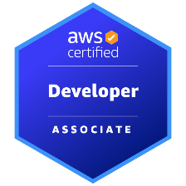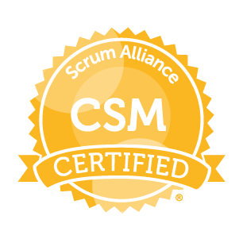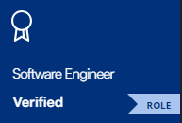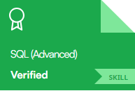

Languages

- English  - Bulgarian  - German | working proficiency level  native  entry level

